Joseph Ayo

Module 10.2 Deliverable – CSD 325

12/15/24

Base Program:

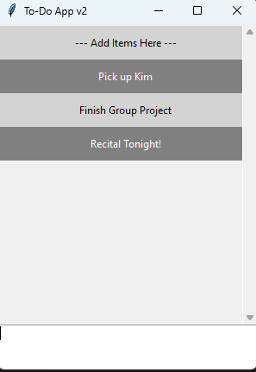

Program after color alterations and adding an Exit function:

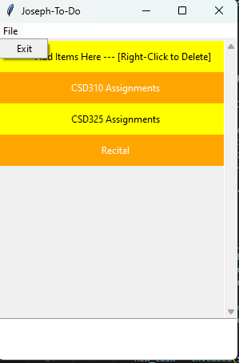

After deleting the ‘Recital’ To-do task in the same instance:

